Surgical Management of Acute Traumatic Lacerations in A 2-Year-Old Intact West African Dwarf Doe: Case Report
Foluso Bolaji-Alabi¹, Olajire Gershon Akangbe¹, Awoyemi Oladotun Solomon¹, Tinubu Oluwaloni Bolaji¹, Popoola Daniel Olutola², Adebiyi Taiwo Kemi²
¹ Department of Veterinary Surgery and Radiology, University of Ibadan
² Veterinary Teaching Hospital, University of Ibadan
Correspondence: folllushoo@yahoo.com
SUMMARY  Traumatic injuries in small ruminants represent significant welfare and economic concerns, particularly when associated with extensive tissue loss and haemorrhage. This report describes the successful surgical management of a severe acute traumatic laceration involving the lateral thoracic musculature in a West African Dwarf goat. The doe presented with a large avulsion wound affecting the lateral thoracic muscles, extending cranially to the region between the forelimbs, and accompanied by substantial blood loss. Initial first aid administered by the owner included wound coverage with clean cloth and application of Gentian violet. Clinical examination revealed a relatively clean wound with exposed musculature and partial rib cartilage involvement. Surgical intervention involved aseptic wound preparation, debridement, lavage, layered closure, and appropriate postoperative care including antimicrobial therapy and analgesia. Healing progressed without complications, and the animal recovered uneventfully. This case highlights the effectiveness of prompt surgical intervention and appropriate postoperative management in achieving favourable outcomes under field condition.  Keywords: Traumatic injury, Wound management, goat, Small ruminants, Surgery | Article History  Submitted: 27 April 2026  Revised: 9 September 2026  Accepted: 11 September 2026  Published: 14 September 2026  Tanzania Veterinary Journal Vol. 41(2)2026  https://doi.org/10.4314/tvj.v41i2.7  ISSN: 0856 - 1451 (Print)  ISSN: 2714-206X (Online)  https://tvj.sua.ac.tz  License terms  This article is available under the terms of the Creative Commons attribution License (CC BY). You are free to use, reproduce, redistribute in any medium or format provided the original publication in this journal is cited.

INTRODUCTION

The primary objective of emergency wound management is the restoration of tissue integrity and function following trauma. Traumatic injuries in livestock are a major cause of morbidity and mortality, with significant implications for animal welfare and farm productivity (Broom and Fraser, 2015; Miranda-de la Lama et al., 2012).
In small ruminants, traumatic lacerations frequently result from environmental hazards, poor housing conditions, and inter-animal interactions, leading to extensive soft tissue damage and haemorrhage. These injuries predispose affected animals to infection, delayed healing, and economic losses if not promptly managed (Constable et al., 2017).
Effective wound management requires rapid clinical intervention, proper aseptic technique, thorough debridement, and appropriate wound closure. Surgical expertise, particularly in achieving proper tissue apposition and minimizing dead space, plays a critical role in determining healing outcomes (Fubini and Ducharme, 2017; Akinrinmade and Adebayo, 2023).
This report describes the successful surgical management of a severe thoracic laceration in a West African Dwarf goat under field conditions.

CASE PRESENTATION

A 2-year-old intact West African Dwarf doe weighing 25 kg was presented with a history of acute trauma sustained the previous night. The injury occurred when the animal attempted to escape from a buck and was pierced by aluminum roofing sheets. On presentation, the doe exhibited a severe avulsion wound involving the right lateral thoracic region, extending cranially between the forelimbs toward the lower cervical region. The owner reported substantial blood loss prior to presentation and had applied Gentian violet with a clean cloth dressing as first aid. The animal was lactating, having kidded three months prior. Clinical examination revealed that the doe was alert and responsive but exhibited pain upon palpation of the wound. Vital parameters were within normal limits: rectal temperature (39.6°C), heart rate (103 beats/min), and respiratory rate (25 breaths/min). Mucous membranes were pink with a capillary refill time of less than 2 seconds. Local examination revealed an extensive open wound with exposed musculature and partial exposure of rib cartilage. The wound margins were irregular, and there was evidence of prior haemorrhage. No signs of infection or gross contamination were observed. Haematological findings showed moderate hyperproteinemia and hyperfibrinogenemia, consistent with acute inflammation (Table 1-2).

.
A | B | C
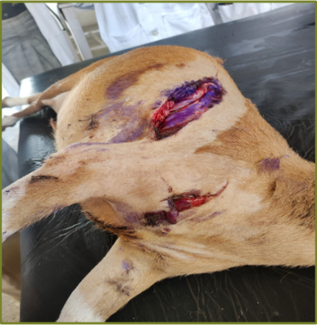

Figure 1. A-C, doe positioned on lateral recumbency for clipping and aseptic preparation

Table 1. Serum chemistry and Haematological parameters readings
Analyte Panel | Unit | Result
Total Protein | g/dl | 8.5
Albumin | g/dl | 3.8
Globulin | g/dl | 4.7
Glucose |  | -
Cholesterol |  | -
Triglycerides |  | -
AST | u/l | 90
ALT |  | -
ALP |  | -
GDH |  | -
SDH |  | -
GGT |  | -
Total Bilirubin |  | -
BUN | mg/dl | 33
Creatinine | mg/dl | 1.5
Parameter | Unit | Patient Value
Plasma Color | — | Normal
Total Protein | g/dl | 9.00
Fibrinogen | g/dl | 100
Hb | g/dl | 6.5
PCV | % | 20
RBC Count | × 10⁶/μl | 7.55
MCV | Fl | 27
MCHC | g/dl | 33
Reticulocytes | % | -
RDW |  | -
Platelet Count | /μl | 114,000
MPV |  | -

Table 2. Differential white blood cell count
Cell Type | Relative Percentage | Absolute Count (/μl)
Total WBC Count | — | 5,150
Segmented Neutrophils | 68% | 3,502
Band Neutrophils | - | -
Lymphocytes | 25% | 1,287
Monocytes | 2% | 103
Eosinophils | 5% | 258
Basophils | - | -
Nucleated RBC | - | -

SURGICAL MANGEMENT

The doe was sedated using xylazine hydrochloride (0.02 mg/kg IM) and positioned in left lateral recumbency. Local anaesthesia was achieved using 2% lidocaine hydrochloride (2 mg/kg) via infiltration around the wound margins. The surgical site was clipped and aseptically prepared. The wound was thoroughly debrided and lavaged using sterile antiseptic solution. Devitalized tissues were excised to create clean wound edges. Layered closure was performed as follows; muscle layers were apposed using a simple continuous suture pattern, skin was closed using horizontal mattress sutures, and dead space was minimized to prevent fluid accumulation.
Postoperative treatment included: oxytetracycline (20 mg/kg IM, long-acting), topical oxytetracycline spray, sterile wound dressing with gauze and bandage. The animal recovered uneventfully.

A | B
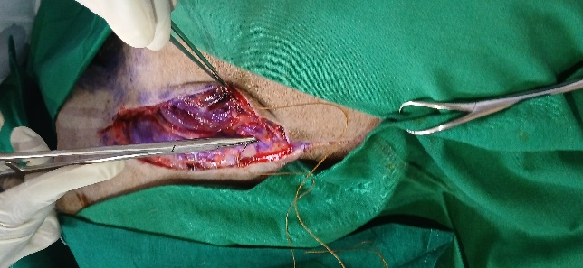
Figure 2. A and B Surgical management of the wound under sedation and local anaesthetic infiltration

A | B
Figure3. A and B wound after apposition of sutures and dressing

A | B | C
Figure 4. A-C, doe represented 7 days post-surgery, suture removed

POSTOPERATIVE OUTCOME AND RESULTS

The surgical intervention was successful, with proper apposition of the wound edges and no immediate postoperative complications recorded. Healing progressed satisfactorily with no postoperative complications. The doe was re-examined every other day till the seventh day after surgery, at which time the wound had healed completely without discharge, infection, or dehiscence. Sutures were removed, and the animal returned to normal activity.
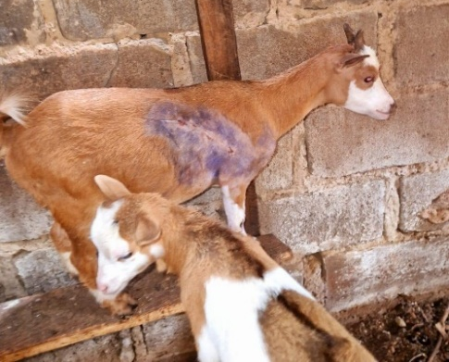
Figure 5: Doe returned to normal activities on the farm

DISCUSSION

Severe traumatic wounds in small ruminants pose significant challenges, particularly in field conditions where resources may be limited. Prompt surgical intervention, including proper debridement and wound closure, is essential for preventing infection and promoting healing (Anderson and Rings, 2009).
The use of xylazine sedation combined with local infiltration anaesthesia provided adequate restraint and analgesia, making it suitable for field surgery in food animals. Early presentation and appropriate postoperative care contributed significantly to the favorable outcome observed in this case.
The absence of complications such as infection or wound dehiscence underscores the importance of aseptic technique, appropriate antimicrobial therapy, and proper wound management. Additionally, this case highlights the need for improved farm management practices to prevent traumatic injuries.

CONCLUSION

Severe thoracic lacerations in goats can be successfully managed through prompt surgical intervention, appropriate anaesthesia, and effective postoperative care. Early veterinary attention and adherence to standard clinical protocols are critical for achieving favorable outcomes in traumatic injuries.

REFERENCES

Akinrinmade, J.F. and Adebayo, O.O. (2023). Field surgical practices in small ruminants in tropical environments. Tropical Animal Health and Production, 55, 112.
Anderson, D.E. and Rings, D.M. (2009). Current veterinary therapy: Food animal practice. 5th ed. Elsevier.
Broom, D.M. and Fraser, A.F. (2015). Domestic animal behaviour and welfare. 5th ed. CABI.
Constable, P.D., Hinchcliff, K.W., Done, S.H. and Grünberg, W. (2017). Veterinary medicine: A textbook of the diseases of cattle, horses, sheep, pigs and goats. 11th ed. Elsevier.
Fossum, T.W. (2018). Small animal surgery. 5th ed. Elsevier.
Fubini, S.L. and Ducharme, N.G. (2017). Farm animal surgery. 2nd ed. Elsevier.
Hendrickson, D.A. (2012). Techniques in large animal surgery. 4th ed. Wiley-Blackwell.
Kumar, V., Abbas, A.K. and Aster, J.C. (2020). Robbins and Cotran pathologic basis of disease. 10th ed. Elsevier.
Miranda-de la Lama, G.C., Villarroel, M. and María, G.A. (2012). Livestock transport from the perspective of the pre-slaughter logistic chain. Animal, 6(9), pp.1485–1493.
Smith, B.P. (2020). Large animal internal medicine. 6th ed. Elsevier.
Abubakar, M.S., et al. (2022). Surgical wound management in small ruminants under field conditions. Veterinary World, 15(3), pp.678–684.
Nwankpa, N.D., et al. (2021). Management of traumatic wounds in goats: A review. Nigerian Veterinary Journal, 42(2), pp.85–92.

